**Experiment 1.3**

**Name :- Yash Gupta Uid :- 20BCS5009**

**Course :- CSE Section :- 704-A**

**Subject :- Programming in Python Subject Code :- 20CSP-259**

1. Write a python program to calculate area of 10 different circles. Given the pie = 22/7 and radius of the circles entered by user using Simple Function , Parameterized Function , Return Type with function and return type with parameterized Functions .

def area_cal(r):

area = (22/7)*(r**2)

print("Area of circle :- {:.2f}\n".format(area))

for i in range(1,11):

radii=float(input("Enter radii for {} circle to calculate area :".format(i)))

area_cal(radii)

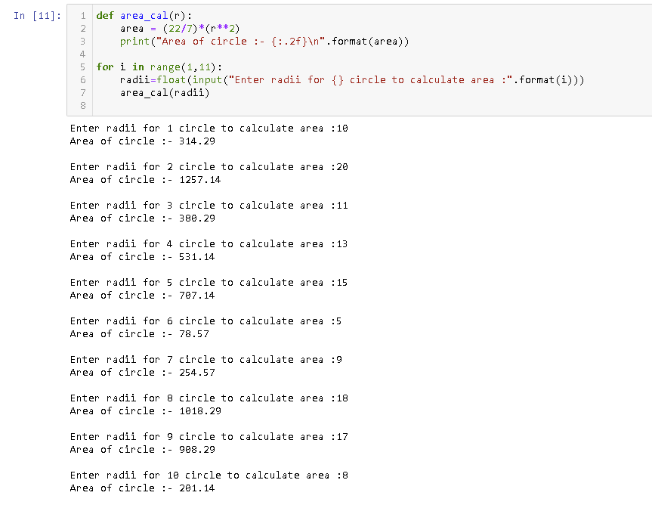

1. Write a python program to print Multiplication tables from 2 to 20 whether table values entered by user using Simple Function , Parameterized Function , Return Type with function and return type with parameterized Functions .

def table(num):

for i in range(1, 11):

print(num, 'x', i, '=', num*i)

a=1

for i in range(1,21):

print("\n ---- Table of {} ----".format(a))

table(a)

a +=1

